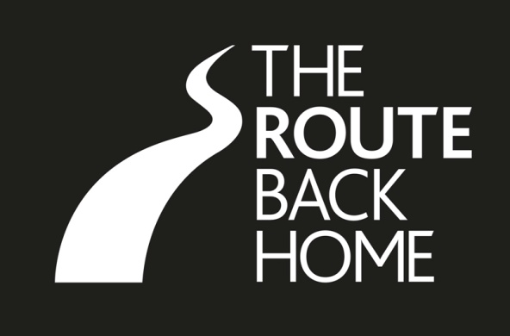
BOOKING FORM

Family History Conference
Ballymoney, Co. Antrim
24-27 September 2014

Name (in BLOCK CAPITALS):
Address:

Post code/Zip code:
Country:
Telephone no.: Email:
Research interest (e.g. family name(s), townlands, historical period): _____________________________________________________

Please tick this box if you do not wish your name and research interests to be included on the conference delegate listing.

Do you require disabled access? (please tick): YES NO

Please provide details of any dietary requirements: ________________________________________________________________

CONFERENCE DELEGATE FEE IS £180. This fee includes an evening reception on Friday 26 September. Delegates are welcome to bring a companion to this reception at an extra charge of £20 for each accompanying individual.

For payment by cheque (£ pounds sterling)
Please make out to Ballymoney Borough Council and send with this booking form.

For payment by credit/debit card
Please complete the following details.
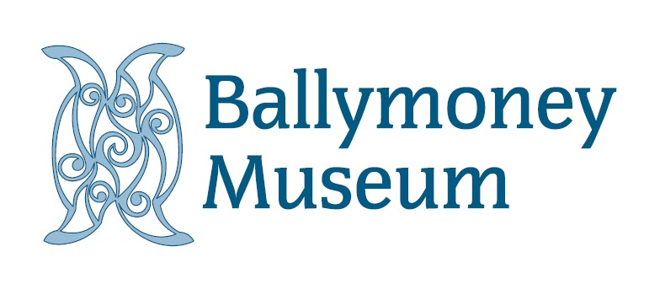
CARD NUMBER: _ _ _ _ _ _ _ _ _ _ _ _ _ _ _ _ EXPIRY DATE: ISSUE NUMBER:

SIGNATURE: SECURITY CODE:
Credit/debit card payments may be made in person at Ballymoney Town Hall, or by telephone + 44 28 2766 0230.
This form must be completed and returned to the following address: Museum Manager, Ballymoney Museum, Ballymoney Town Hall,
Townhead Street, Ballymoney, County Antrim, BT53 6BE or Email: museum@ballymoney.gov.uk.

